VERILIO

Planning Statement
Document type: Planning Statement
Property / site: 14 Willow Close, Dereham, Norfolk, NR19 2XX
Application type: Rear Extension
Project: A single-storey rear extension to create a larger kitchen/dining room.

Document

1. Introduction
This Planning Statement relates to a rear extension at 14 Willow Close, Dereham, Norfolk, NR19 2XX.

2. Site and Surroundings
The site is located at 14 Willow Close in Dereham, Norfolk. A location plan, as detailed in "03 Location and Site Plan.pdf," shows the property in context with neighbouring properties. Information about townscape, neighbours and designations has not been verified.

3. Proposal
The extension would provide kitchen and dining area. The applicant has stated that there has been no previous enlargement of the original house. The design will maintain private garden or external space. The proposed floor plan is detailed in "02 Proposed Ground Floor Plan.pdf."

4. Planning Route
Based on the information currently available, the proposal may fall within permitted development provisions. This has not been confirmed conclusively and remains subject to the applicable conditions, restrictions and site-specific circumstances. This is not a legal determination.

5. Planning Policy Framework
Proposals are assessed against the development plan and the National Planning Policy Framework, together with any other material considerations. No adopted local development-plan framework has been verified for this statement.

6. Planning Considerations

Amount and Scale
The extension has an approximate projection of 3.5m and a height of 3.6m, as stated by the applicant. This has not been independently measured. Details can be found in "02 Proposed Ground Floor Plan.pdf."

Layout
As per the applicant's statement and "02 Proposed Ground Floor Plan.pdf," the proposal involves adding a kitchen and dining area. There has been no previous enlargement of the original house.

7. Design and Residential Amenity
The proposed materials are brickwork to match the existing house, with a flat roof and rooflight. New dark grey uPVC windows and doors are planned, as shown in "05 Proposed Elevations.pdf."

8. Environmental / Heritage Considerations
Initial screening indicates that the proposal may fall within a Biodiversity Net Gain exemption applicable to householder development. This screening does not replace confirmation of the application's exemption status or any site-specific assessment. Nutrient neutrality has been identified as potentially relevant by Verilio's initial screening. Further checking of the applicable catchment, drainage arrangements and wastewater arrangements is required before determining whether any nutrient-neutrality requirements apply.

9. Planning History
Planning history has not been established from the available Planning Data. This is not a complete planning-history search. A local planning-register search is not available for this authority yet. That is not a finding that there is no planning history.

10. Conclusion
In summary, the proposal is a rear extension designed to provide a kitchen and dining area at 14 Willow Close. The proposal may fall within permitted development provisions, but that has not been confirmed. This statement is not a planning-authority decision.

Appendix — proposal drawings
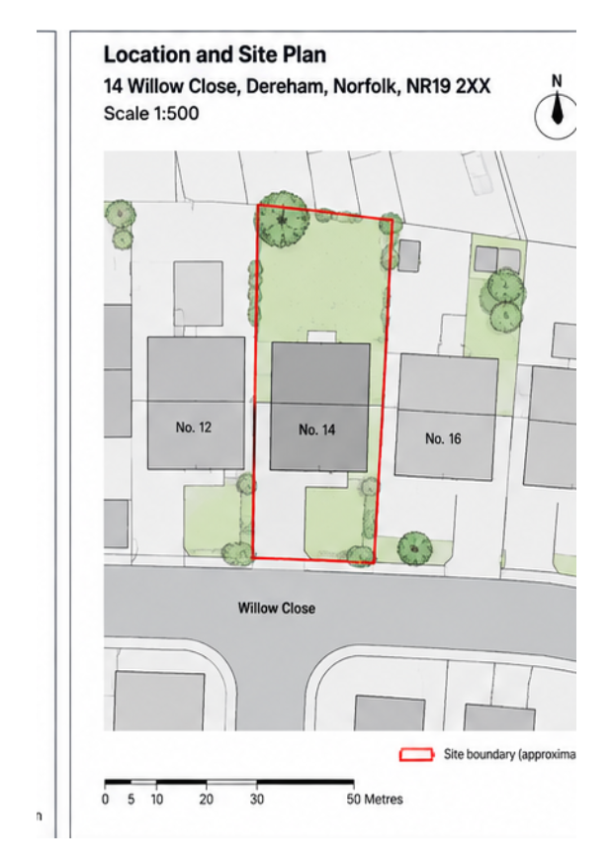
03 Location and Site Plan.pdf
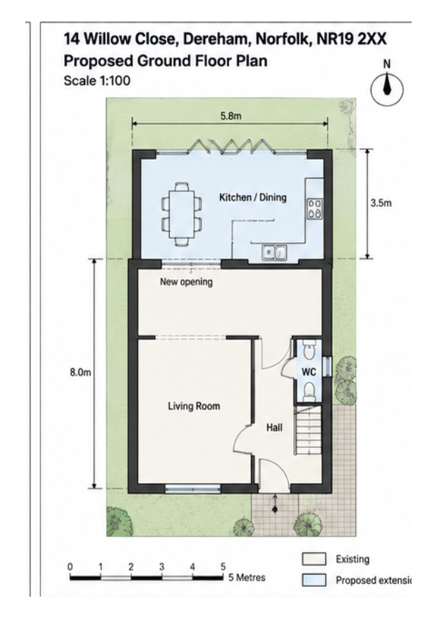
02 Proposed Ground Floor Plan.pdf
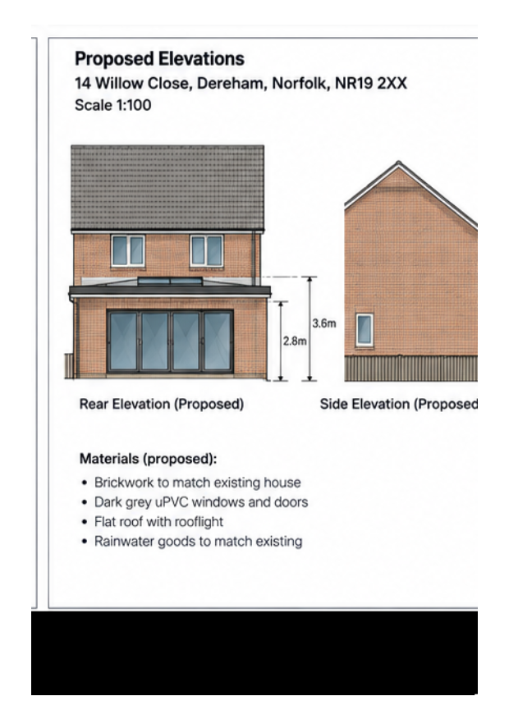
05 Proposed Elevations.pdf

