VERILIO

Design and Access Statement
Document type: Design and Access Statement
Property / site: 14 Willow Close, Dereham, Norfolk, NR19 2XX
Application type: Rear Extension
Project: A single-storey rear extension to create a larger kitchen/dining room.

Document

1. Introduction
This Design and Access Statement concerns the proposed single-storey rear extension at 14 Willow Close, Dereham, Norfolk, NR19 2XX. The extension would provide kitchen and dining area. The extension is proposed to provide additional kitchen and dining accommodation and enlarge the existing facilities within the dwelling. This statement has been prepared to outline the proposal based on available information and applicable design considerations. This Design and Access Statement describes a householder enlargement of an existing dwelling rather than the creation of a separate residential unit. It is based on the established information for the proposed development.

2. Site and Surroundings
The property is described as currently used as a residential dwellinghouse. Available screening has not identified a conservation area or other immediate heritage designation affecting the site. This should be confirmed against current local authority records before submission.

3. Amount
The stated projection is 3.5 metres. That figure has not been independently surveyed. The stated overall height is 3.6 metres. That figure has not been independently surveyed. This enlargement will provide an expanded kitchen and dining area within the existing residential use. Please refer to 02 Proposed Ground Floor Plan.pdf for additional context.

4. Layout
The extension is positioned at the rear of the existing house, facilitating a larger kitchen and dining area. The extension would provide kitchen and dining area. Refer to 02 Proposed Ground Floor Plan.pdf for layout details. The applicant has indicated that private garden or external space would remain. The named accommodation is established. Detailed internal arrangement and circulation remain to be confirmed by drawings.

5. Scale
The proposed extension is single storey and projects approximately 3.5 metres from the rear of the dwelling. These dimensions are based on the information provided and have not been independently surveyed. The stated overall height is approximately 3.6 metres.

6. Appearance
The proposed extension features external walls in red/buff brickwork intended to match the existing house, with a low-pitched/flat roof incorporating a rooflight. New windows and doors are planned, using dark grey uPVC. This is shown on 05 Proposed Elevations.pdf. This is drawing information, not independently verified.

7. Landscaping and External Space
The applicant has indicated that existing garden or external space will be retained. Landscaping changes are not detailed and the adequacy of the retained area has not been assessed against potential amenity standards. This is applicant-indicated information.

8. Access
Pedestrian and vehicle access to the site will remain unchanged. Further details can be confirmed in 03 Location and Site Plan.pdf.

9. Residential Amenity
The extension is described as close to a boundary. Privacy, overlooking and neighbour effects have not been established. It is crucial to assess these relationships to ensure residential amenity is considered appropriately. The applicant indicates that private garden or external space would remain, though its adequacy has yet to be evaluated.

10. Design Response
The addition of new windows and doors would blend with the dwelling's current style. The established design information identifies a rear location relative to the existing dwelling, a single-storey form, a Low-pitched/flat roof with a rooflight, retained external space and unchanged pedestrian and parking arrangements.

11. Environmental and Heritage Considerations
The available environmental screening has identified matters requiring further checking, including potential nutrient-neutrality relevance. Available screening suggests that a Biodiversity Net Gain exemption for householder development may be relevant, though this requires confirmation. Nutrient neutrality is flagged as potentially relevant, necessitating further investigation into drainage and wastewater arrangements. Nutrient neutrality has been identified as potentially relevant by Verilio's initial screening. Further checking of the applicable catchment, drainage arrangements and wastewater arrangements is required before determining whether any nutrient-neutrality requirements apply.

12. Conclusion
The proposal is a single-storey rear extension to an existing dwelling. The extension would project approximately 3.5 metres. The extension would provide kitchen and dining area. The established design information identifies a Low-pitched/flat roof with a rooflight and new or altered windows and doors. Ridge height, eaves height and window or door detailing remain not independently established where they are not set out in this statement. Relevant environmental matters remain subject to further checking.

Appendix — proposal drawings
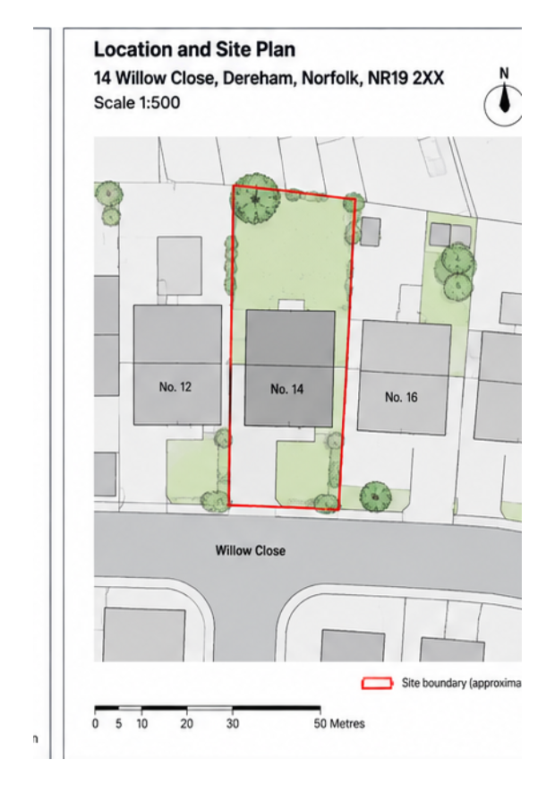
03 Location and Site Plan.pdf
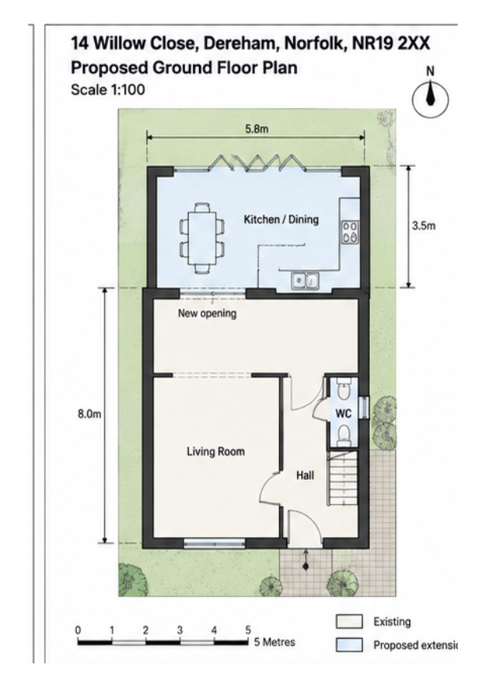
02 Proposed Ground Floor Plan.pdf
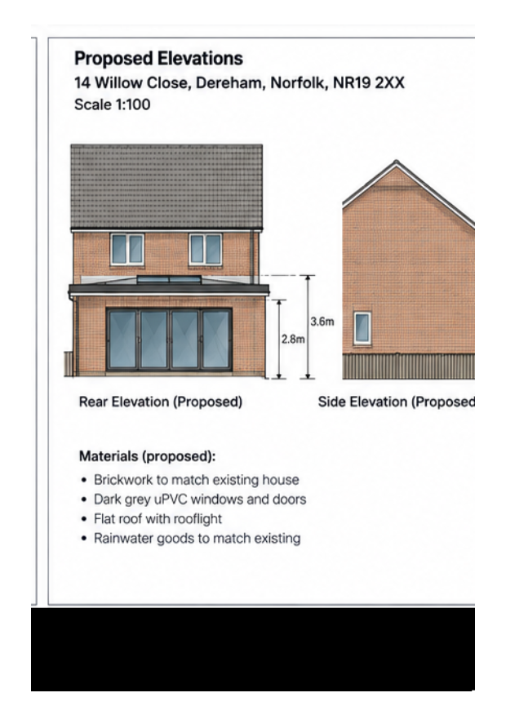
05 Proposed Elevations.pdf

